**Exercise 6: Cursors**

**Scenario 1:** Generate monthly statements for all customers.

**Script Output and DBMS Output:**

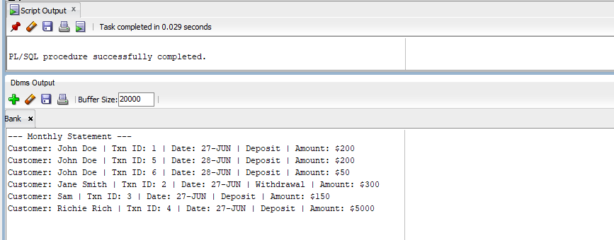

**Scenario 2:** Apply annual fee to all accounts.

**Script Output and DBMS Output:**



**Scenario 3:** Update the interest rate for all loans based on a new policy.

**Script Output and DBMS Output:**

